Radford Child Development  
WordPress Administration

**Credentials**

[Https://rcd.michaelyopp.com/wp-admin](https://rcd.michaelyopp.com/wp-admin)

Username: rcd_admin

Password: TzOM*E8^awA3SXHwA6

**Server Specific Information**

OS: CentOS 7.3

SSH/SFTP

Host: rcd.michaelyopp.com  
User: root

Pass: ITEC471Group3#!

Database

Host: <https://rcd.michaelyopp.com/phpmyadmin>

User: rcd_dev

Pass: 7u3xe46rq982tNGM

VHOST Configs: /etc/httpd/conf.d/vhost/  
Sites: /var/www/html

**Back-up The Website**

*(The entire Vm/VPC is backed up daily with a 14 day retention policy)* **Backup Entire Site**

1. Log in to wordpress as an administrator

2. Click All-In-One WP Migration on the left hand side menu  
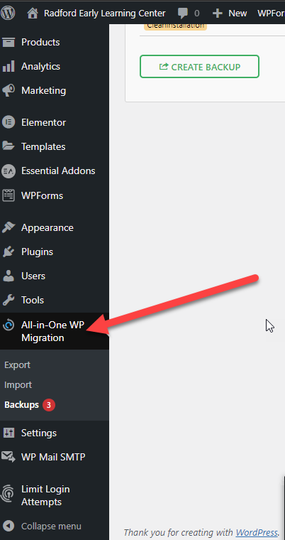

3. Click Create Backup  
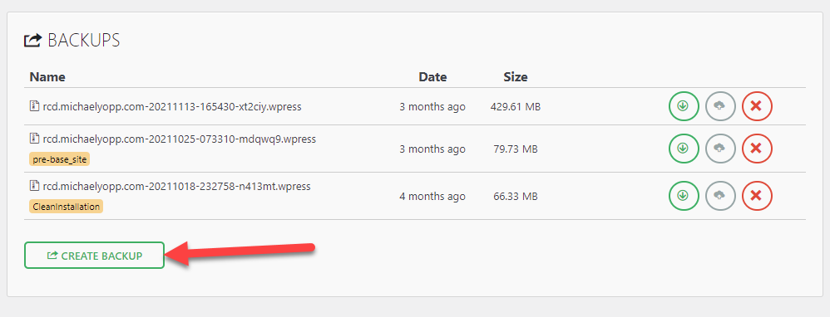

4. Click the download button for the backup we just created to download to your computer  
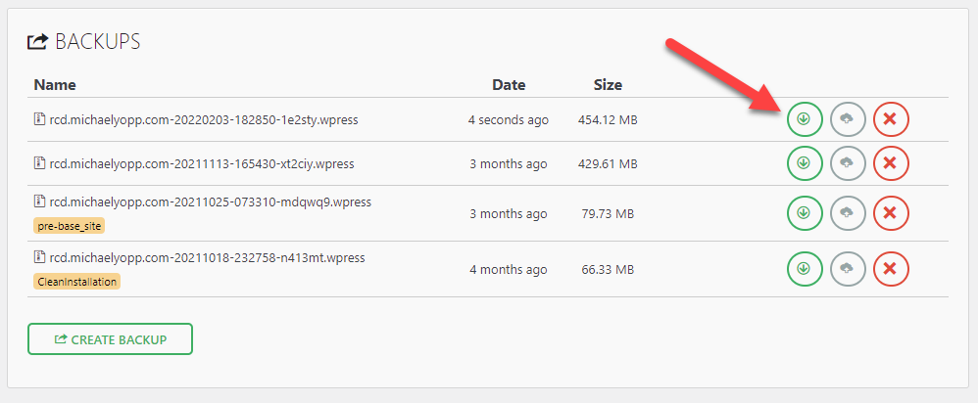

5. The file will begin downloading  
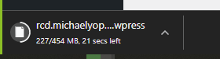

**Restore Website**

(*In order to do a restore you must have the back from the previous steps*)

Click All-In-One WP Migration and then Import  
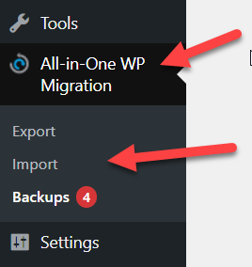

Select the File To Import  
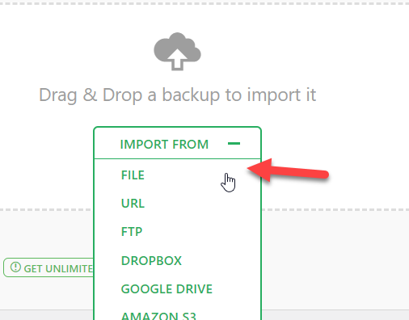

**Installing Updates**

Once logged in Click Dashboard and then Updates

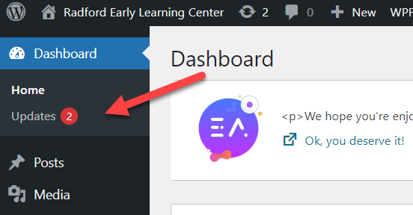

Click Select All and Update Plugins  
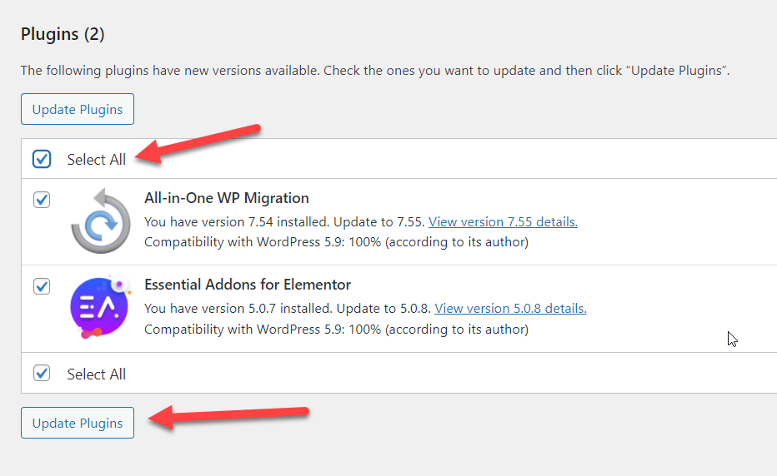

You will receive a report about the updates and if the installed correctly  
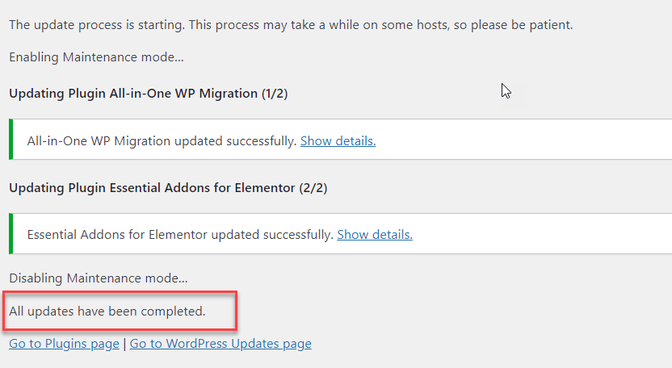

**Editing Page Contents**

1. Make sure you’re logged in.
2. Go to page you intend to edit, for example ‘Our Partners Page’
3. Select Edit with Elementor

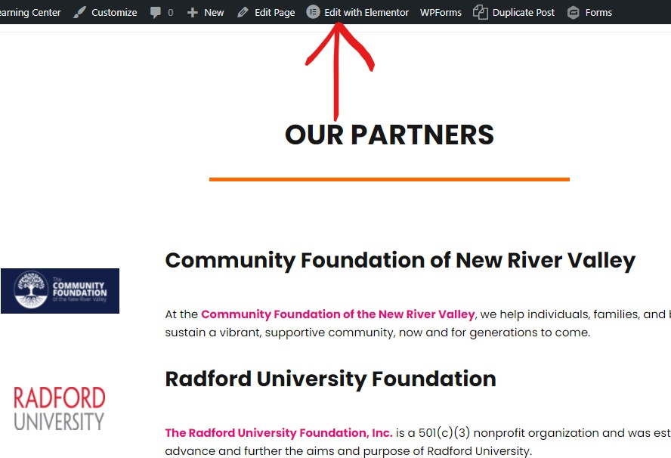

1. Hover over what content you’d want to edit, for example the header,”OUR PARTNERS”, and click the edit icon in the right corner.

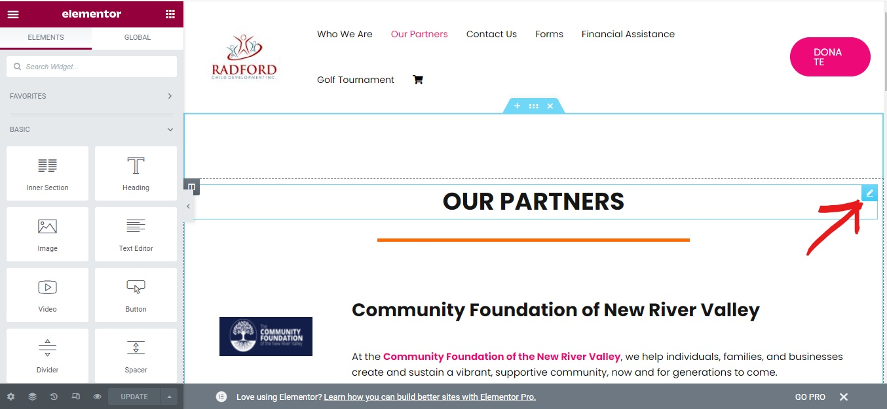

1. Change text in the textbox under title, and click the green update button at the bottom.

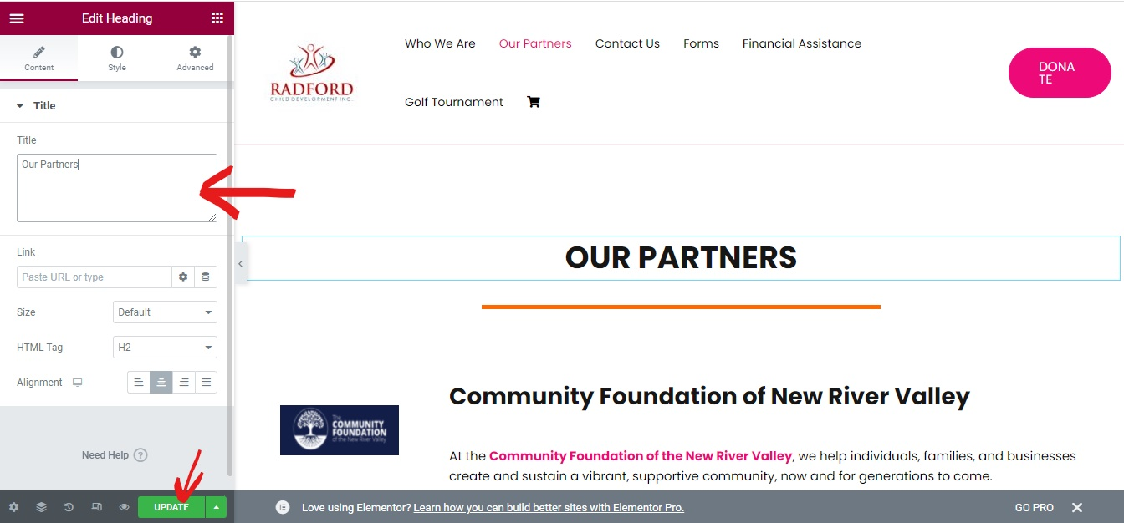

**Embedding Link in Picture**

1. Follow the directions of ,”Editing Page Contents “, till step 4.
2. Hover over an image, example the Logo for the Community Foundation of New River Valley and click the edit button at the right corner.

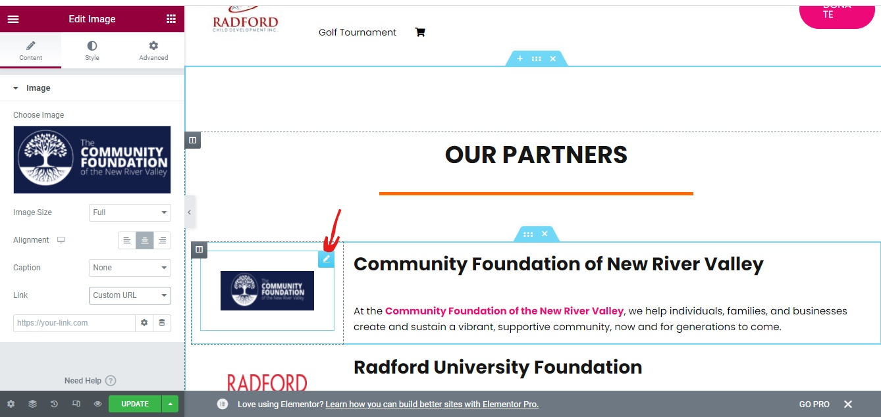

1. On the left side panel select Custom URL from the Link dropdown Menu.

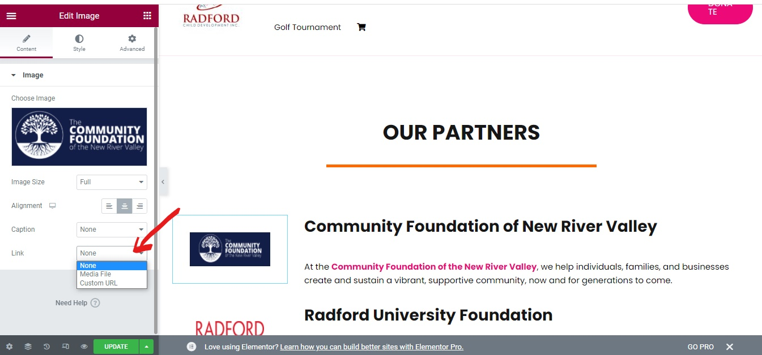

1. A textbox will appear below, where you can insert the link. Click the green Update button to update the page.

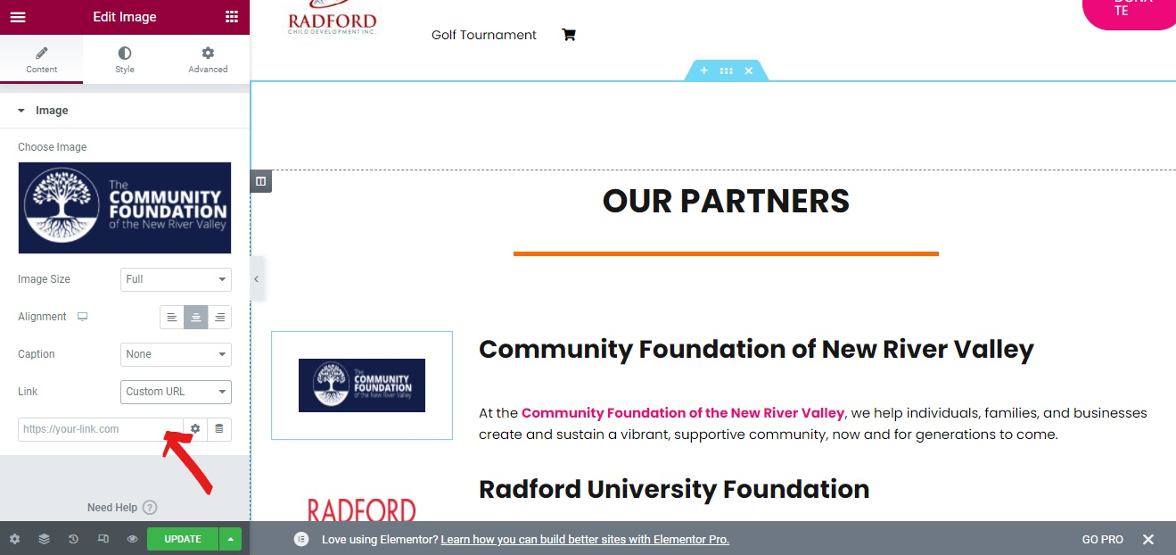

# **Adding a Page**

1. Login into dashboard with credentials.
2. On the left panel, click pages

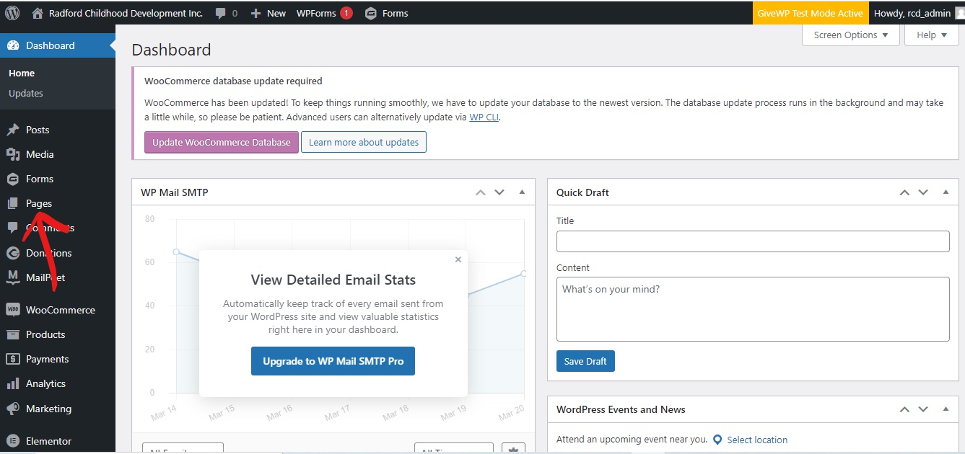

1. Click the “add new” button at the top of the pages page.

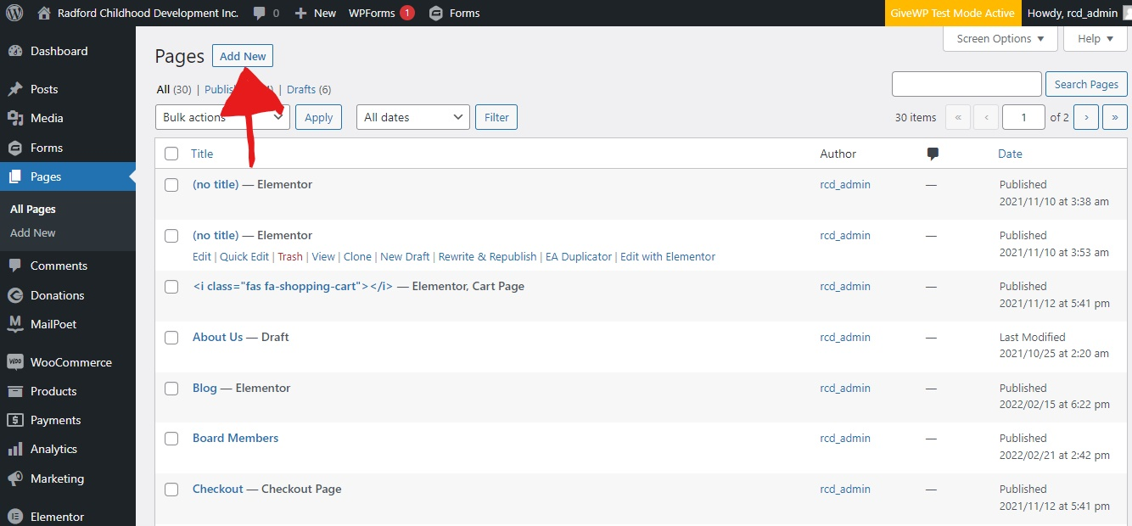

1. You’ll be brought to this page, where you’ll type the name of the page where it says, “Add Title”. After adding the title, click the publish button at the top right corner.

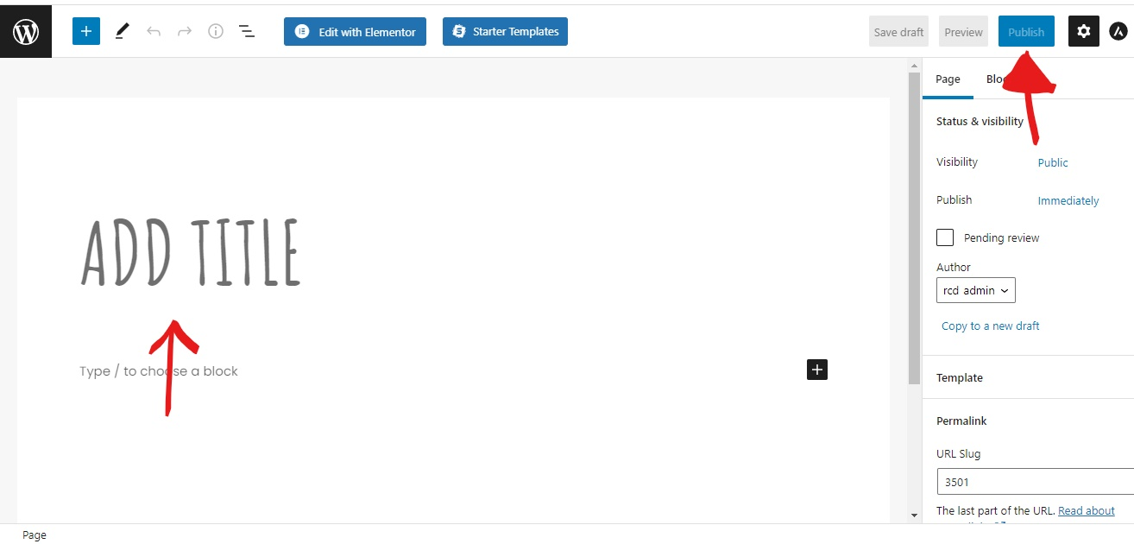

1. You see a pop-up that says, “Page published”.

# **Adding new page to Menu**

1. Log into dashboard, if you have not already.
2. On the left panel, scroll down to appearance, hover over it and click “Menus”.

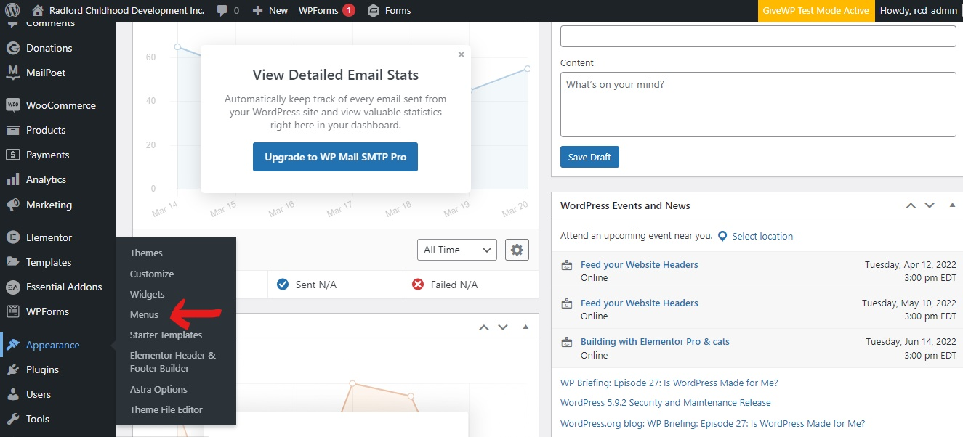

1. Make sure where there’s a label called, “Select Menu to edit”, that its value is “Primary Menu (Primary Menu)”.
2. On the left panel, under the “Most Recent” tab, select the page you just created. Then click the add to menu button. Finally click the “Save Menu” button on the bottom right corner.

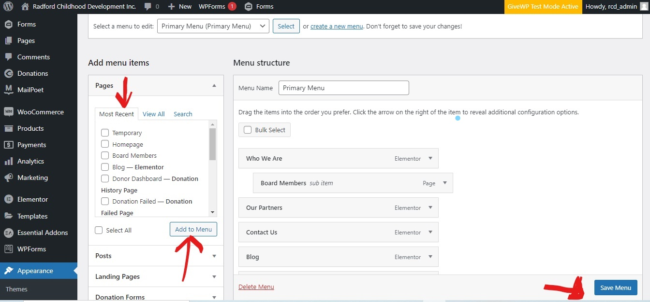

# **Removing Pages**

1. Log into Dashboard, if you haven’t already.
2. On the left panel, click “Pages”.



1. In the search bar at the top right, search for the name of the page you want to delete.

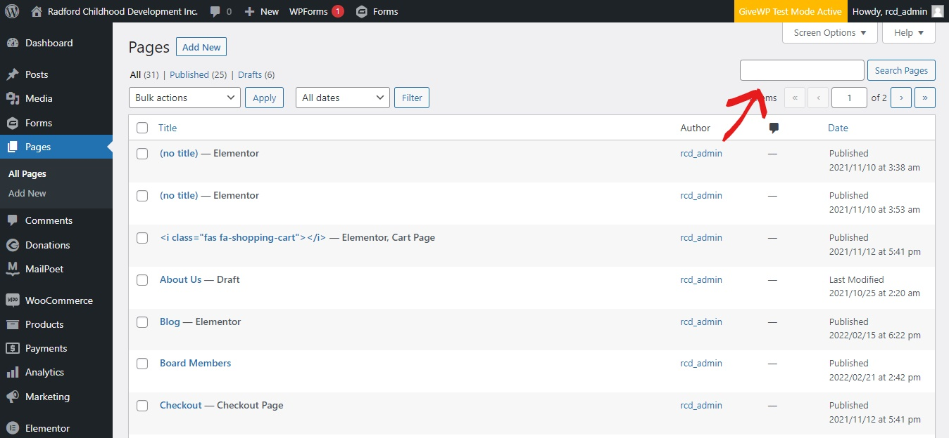

1. Hover over the searched page, and a list of options will appear, select the “Trash” option.

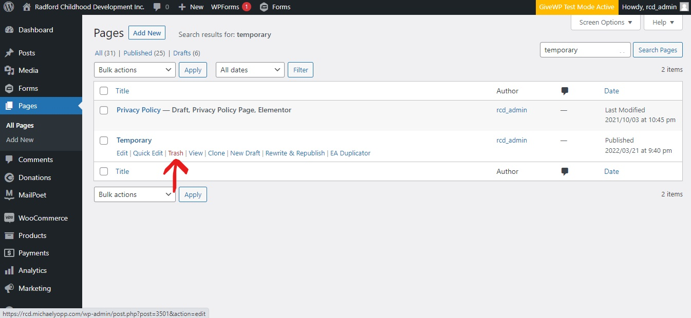

1. You will see a pop up saying, “1 paged moved to trash”.
2. Now click the “Trash link” above the “Apply” button.
3. You’ll now see the page,you sent to the trash.
4. Click the empty trash button.

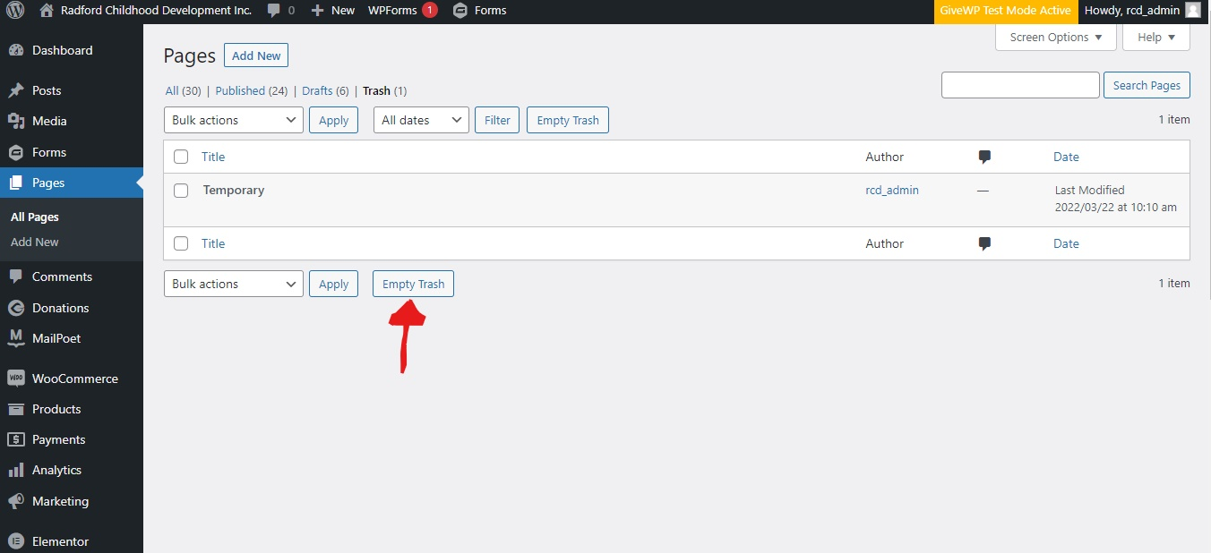

1. You’ll see a pop up saying, “1 page permanently deleted”.